IREVOLUTION : A DATA-DRIVEN EXPLORATION OF APPLE’S IPHONE

1.Introduction:

1.1.Overview:

"IRevolution: A Data-Driven Exploration of Apple's iPhone Impact in India" is a research report that delves into the significant influence of Apple's iPhone on India's smartphone market and its broader societal implications. This report offers a comprehensive overview of the research's purpose, scope, and key areas of focus:

1. **Smartphone Revolution**: The report acknowledges the transformative impact of smartphones on the world, particularly the iPhone, which has been instrumental in enhancing communication, connecting people, and reshaping various industries.
2. **Apple's Prominence**: It recognizes Apple Inc. as a leading player in the global smartphone market, with the iPhone capturing markets worldwide. Apple's products have had a substantial impact on the tech industry.
3. **India's Growing Market**: India, with one of the fastest-growing economies, has witnessed a remarkable surge in smartphone usage. The report highlights India's significance as a market and a case study for examining the effects of Apple's iPhone.
4. **Data-Driven Approach**: The research report distinguishes itself by adopting advanced data analytics techniques and analyzing extensive datasets. This data-driven approach is crucial in providing accurate insights into the impact of the iPhone in India.
5. **Key Investigative Areas**: The primary focus of the research is to explore critical factors such as market penetration, customer preferences, economic consequences, and societal changes resulting from the iPhone's presence in India.
6. **Market Potential**: With India's vast population and increasing smartphone adoption rates, the report emphasizes the unique opportunity for Apple to expand its market share and establish a significant presence in India.
7. **Consumer Excitement**: The report acknowledges the enthusiasm and anticipation among Indian consumers surrounding each new iPhone model release, underscoring the brand's strong appeal in the Indian market.

The overarching objective of this research is to move beyond conjecture and anecdotal evidence, using rigorous data analysis to gain a deep understanding of how the iPhone has shaped India's technological landscape, economy, and the lives of its people. It serves as a comprehensive exploration of the multifaceted impact of Apple's iPhone in the Indian context.

1.2.Purpose:

The purpose of the research report, "iRevolution: A Data-Driven Exploration of Apple's iPhone Impact in India," is multi-faceted and encompasses several key objectives:

1. **Understanding Market Penetration:** The primary purpose is to gain insights into the extent of Apple's iPhone penetration in the Indian smartphone market. This involves quantifying its market share and understanding its competitive position.
2. **Analyzing Customer Preferences:** The report seeks to analyze consumer preferences and behaviors related to iPhones in India. This includes understanding why people choose iPhones over other smartphone brands and models.
3. **Assessing Economic Ramifications:** The research aims to uncover the economic implications of the iPhone's presence in India. This may include examining its contribution to India's economy, such as through job creation, manufacturing, and related industries.
4. **Exploring Societal Changes:** The report intends to delve into the societal changes brought about by the widespread adoption of iPhones in India. This may encompass changes in communication patterns, social interactions, and access to information and services.
5. **Data-Driven Insights:** By utilizing advanced data analytics techniques and analyzing large datasets, the research's purpose is to provide evidence-based insights. This means moving beyond anecdotal evidence and speculations to offer a comprehensive and data-driven understanding of the iPhone's impact.
6. **Market Potential for Apple:** The research also highlights the opportunity that India's large and growing population presents for Apple to expand its market share. Understanding this potential is crucial for Apple's strategic decision-making.
7. **Anticipating Consumer Behavior:** Recognizing the excitement and anticipation generated by new iPhone model releases among Indian consumers, the research aims to anticipate and understand the factors driving consumer behavior in the Indian market.

In summary, the primary purpose of this research is to offer a comprehensive and data-driven exploration of the impact of Apple's iPhone in India. It seeks to provide valuable insights into the changing technological landscape, the evolving economy, and the societal transformations resulting from the iPhone's presence in India. Ultimately, this research is intended to inform business strategies, policy decisions, and public discourse related to Apple's role in India's smartphone market and its broader implications.

2.Problem Definition & Design Thinking:

2.1.Empathy Mapping:

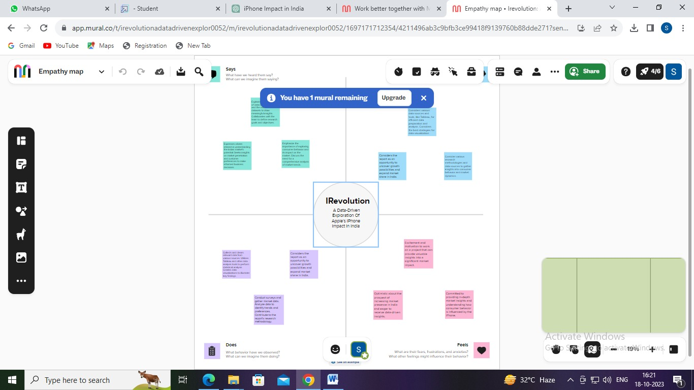2.2.Brainstorming: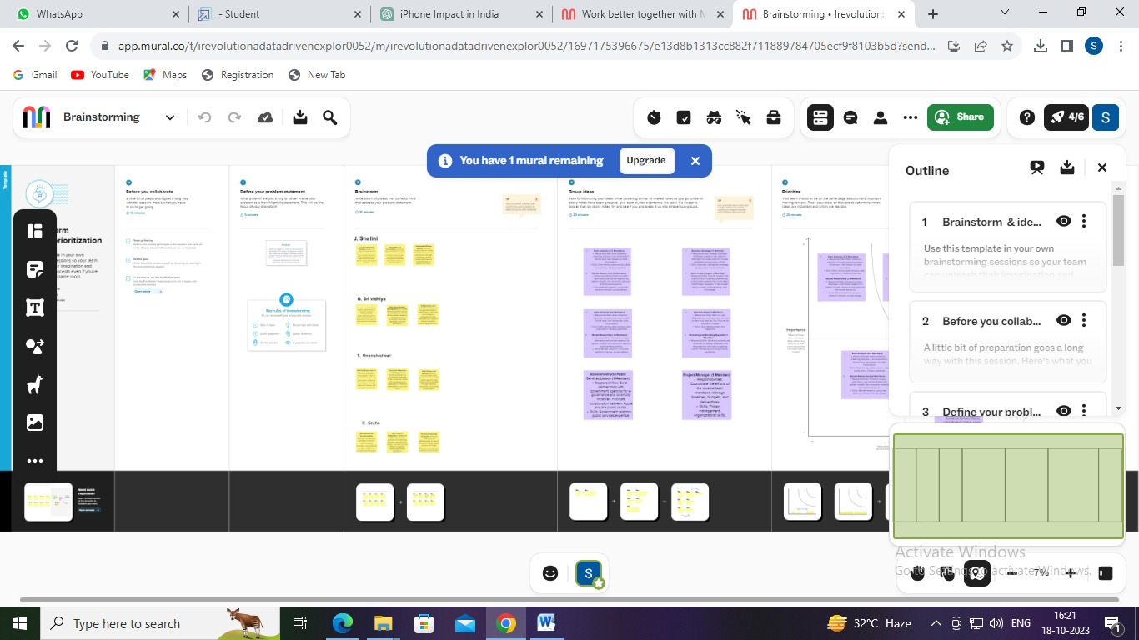

3.Result:

3.1.Dashboard:

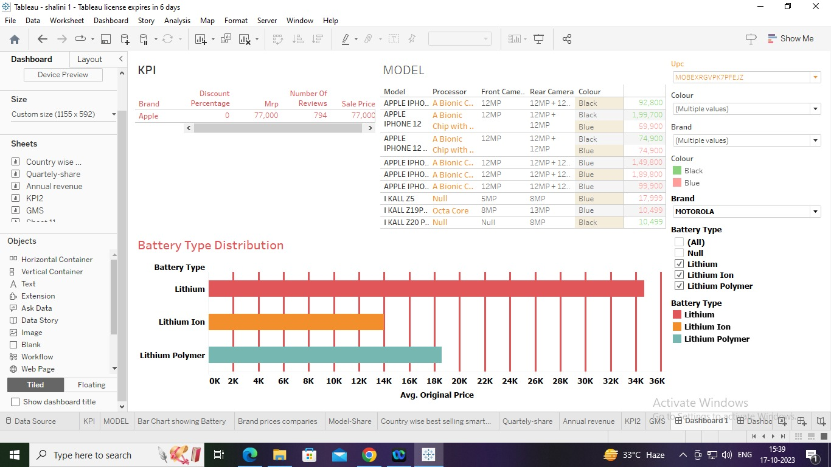

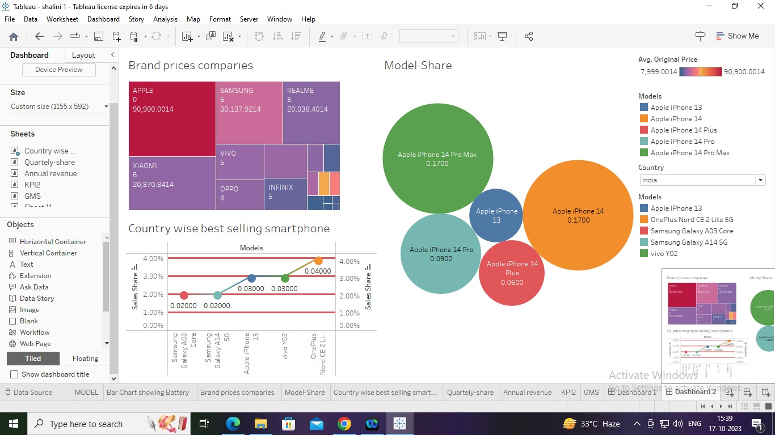

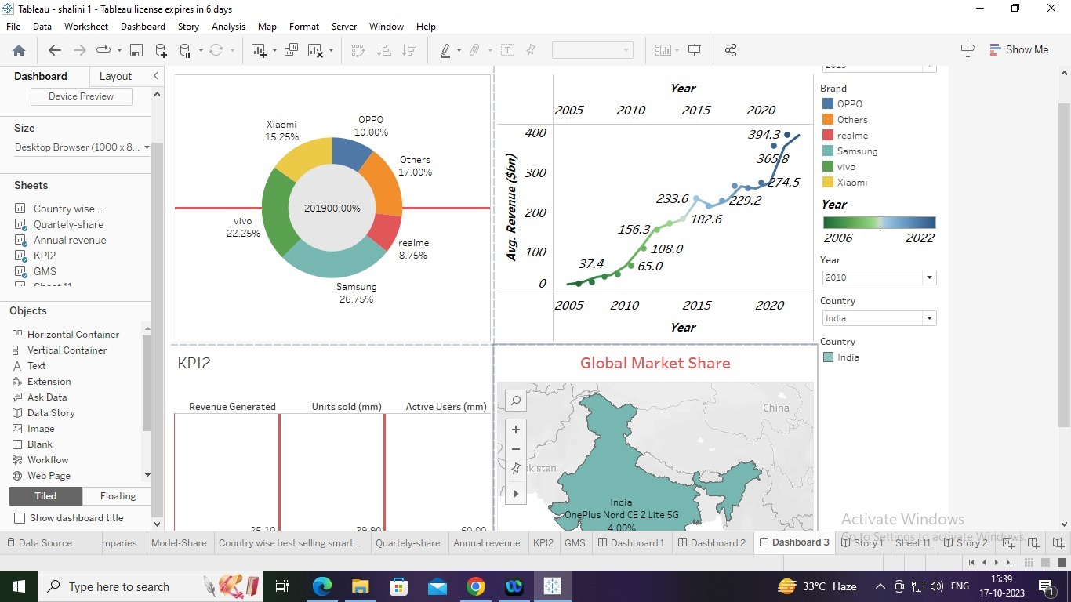

3.2.Stories:

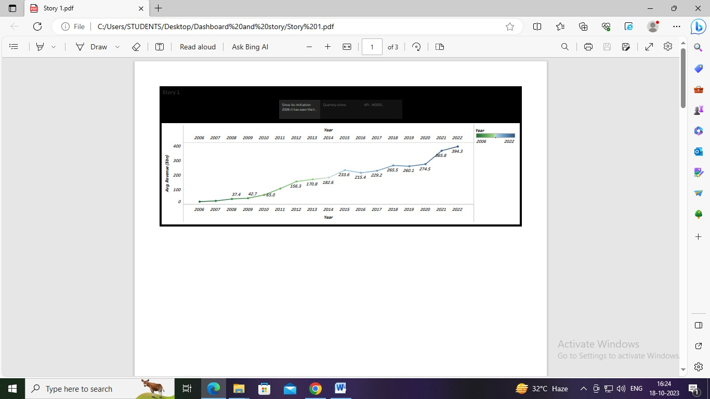

4.Advantages and Disadvantages:

4.1.Advantages:

**The research report titled "iRevolution:** A Data-Driven Exploration of Apple's iPhone Impact in India" offers several advantages, both in terms of its approach and its potential impact. Here are some of the advantages of this research:

1. **Data-Driven Insights:** The research relies on advanced data analytics techniques and the analysis of extensive datasets. This data-driven approach provides a high degree of accuracy and objectivity, ensuring that the insights and findings are based on concrete information rather than speculation.
2. **Comprehensive Understanding:** By examining multiple aspects such as market penetration, consumer preferences, economic effects, and societal changes, the research aims to provide a holistic understanding of the iPhone's impact in India. This comprehensive view is valuable for stakeholders in various fields.
3. **Strategic Decision-Making:** Businesses, including Apple, can benefit from the research's findings to make informed strategic decisions regarding their operations in the Indian market. Understanding consumer preferences and market dynamics is crucial for success.
4. **Policy Formulation**: Policymakers can use the insights from this research to formulate and adjust policies related to the smartphone industry, trade, and technology adoption in India. It can help in creating a conducive environment for technology companies and fostering economic growth.
5. **Economic Impact Assessment:** The research aims to assess the economic implications of the iPhone's presence in India. This information can be used to understand the iPhone's contribution to job creation, revenue generation, and related economic activities.
6. **Societal Implications:** By exploring societal changes resulting from the widespread use of iPhones, the research contributes to a broader societal understanding of how technology is influencing communication, social behavior, and access to information.
7. **Global Context:** The research provides valuable information about Apple's global expansion and the strategies employed in emerging markets like India. This can be of interest to global investors, analysts, and other smartphone manufacturers.
8. **Competitive Insights:** Competing smartphone manufacturers can gain insights into how Apple has succeeded in the Indian market, potentially offering lessons and strategies for their own market approaches.
9. **Consumer Behavior Understanding:** By acknowledging the anticipation generated by iPhone launches in India, the research sheds light on factors that drive consumer behavior. This is invaluable for marketing and product development strategies.
10. **Knowledge Advancement:** The research contributes to the body of knowledge related to the impact of smartphones on emerging economies, offering lessons and observations that can be applied to other regions facing similar trends.

In summary, the research report offers a valuable and in-depth analysis of Apple's iPhone impact in India, with data-driven insights that can inform a wide range of stakeholders, from businesses and policymakers to researchers and consumers. It has the potential to shape strategies and decisions in various domains and contribute to a broader understanding of the smartphone industry's role in emerging markets.

4.2.Disadvantages:

**While the research report titled "iRevolution:** A Data-Driven Exploration of Apple's iPhone Impact in India" has several advantages, it may also have some potential disadvantages and limitations, which are important to consider:

* **Data Availability and Quality:** The quality and availability of data can be a limitation. Inaccurate or incomplete data can lead to flawed conclusions. Access to comprehensive and reliable datasets is essential for the success of data-driven research.
* **Data Bias:** Data sources may carry inherent biases, which can skew the results. For example, if the data is primarily sourced from a specific demographic or socioeconomic group, the findings may not represent the entire Indian population accurately.
* **Time Sensitivity:** The research may become quickly outdated due to the fast-paced nature of the technology industry. Consumer preferences, market dynamics, and economic conditions can change rapidly, making it challenging to maintain the research's relevance.
* **Privacy Concerns:** Data collection and analysis may raise privacy concerns. Researchers must handle personal and sensitive information with care to protect individuals' privacy and comply with data protection regulations.
* **Generalization:** Findings from this research may not be universally applicable. India is a diverse country with variations in culture, language, and socioeconomic factors. Generalizing findings to the entire nation can oversimplify complex dynamics.
* **Limitation to iPhone:** Focusing solely on the impact of iPhones may overlook the broader smartphone market in India. Different smartphone brands and models may have unique effects that are not addressed in the research.
* **Market Dynamics:** Market dynamics can be influenced by various external factors, such as government policies, global economic conditions, and competitive pressures. These external forces may not be fully accounted for in the research.
* **Causation vs. Correlation:** Correlations observed in the data do not always imply causation. While the research may identify relationships between iPhone adoption and certain outcomes, establishing causation is often complex.
* **Subjectivity in Interpretation:** Data interpretation and analysis may involve some subjectivity. Different analysts may draw different conclusions from the same dataset, potentially leading to varying interpretations.
* **Resource Intensive:** Conducting data-driven research of this nature can be resource-intensive, requiring access to specialized tools, expertise, and financial resources. This may limit the scope and scale of the research.
* **Ethical Considerations:** The research may raise ethical questions regarding the impact of technology on society, particularly with regards to consumer behavior and societal changes. Ethical dilemmas must be carefully addressed.
* **Influence of Apple:** Depending on the source of funding or potential collaboration with Apple Inc., there could be a perceived or actual bias in the research findings, which may undermine its credibility.

It's important for the researchers to be aware of these disadvantages and limitations and to take measures to mitigate them to the best of their ability, ensuring the research is conducted with rigor, transparency, and ethical considerations. Additionally, researchers should clearly communicate the scope and potential biases of the study to the audience to provide a balanced and accurate perspective.

5.Applications:

**The research report titled "iRevolution:** A Data-Driven Exploration of Apple's iPhone Impact in India" has several potential applications and can be valuable in various contexts. Here are some of the key applications:

* **Business Strategy Development:** Businesses operating in the Indian smartphone market, including Apple, can use the research findings to inform their strategic decisions. This includes product development, marketing, pricing, and distribution strategies.
* **Market Entry and Expansion:** For companies looking to enter or expand in the Indian market, the research can offer insights into the competitive landscape and consumer preferences, helping them make informed market entry and expansion decisions.
* **Policy Formulation:** Policymakers and government authorities can use the research to design policies that support the growth of the technology and smartphone industry in India. This includes regulatory frameworks, tax policies, and incentives for manufacturers.
* **Investment Decisions:** Investors, both domestic and international, can use the research to assess the potential of the Indian smartphone market and make investment decisions in companies operating in this sector.
* **Academic Research:** Researchers in the fields of economics, technology, and sociology can use the research as a reference for academic studies and as a source of data for their own research projects.
* **Marketing and Advertising:** Marketing professionals can utilize the research to better understand consumer behavior and preferences in India, helping them design more effective advertising and marketing campaigns.
* **Consumer Insights:** Consumers can benefit from the research by gaining a deeper understanding of how the iPhone and smartphones, in general, impact their lives and society. This knowledge can inform their purchasing decisions.
* **Global Market Analysis:** The research can be used to draw insights and comparisons with other emerging markets and can serve as a case study for how technology companies like Apple can succeed in such markets.
* **Technology Innovation:** Technology companies can draw inspiration from the research to develop innovative products and services tailored to the specific needs and preferences of the Indian market.
* **Societal Impact Assessment:** Non-governmental organizations (NGOs) and social researchers can use the research to assess the societal implications of smartphone adoption and identify areas where technology can be leveraged for social good.
* **Educational Purposes:** The research can be incorporated into educational curricula to teach students about the impact of technology on economies and societies, especially in emerging markets.
* **Public Awareness:** The findings can be used to raise public awareness about the positive and negative consequences of smartphone adoption and to promote responsible usage.

Overall, the research report has the potential to influence a wide range of stakeholders and decisions, from business and government strategies to academic research and consumer choices. Its applications extend to areas where a deeper understanding of technology's impact on society and the economy is essential.

6.Future Scope:

**The research report "iRevolution:** A Data-Driven Exploration of Apple's iPhone Impact in India" provides valuable insights into the current impact of iPhones in the Indian smartphone market and society. Its findings can also have implications for future research and developments in several areas:

* **Longitudinal Studies:** Researchers can build upon this research by conducting longitudinal studies to track how the impact of iPhones in India evolves over time. This can provide a deeper understanding of trends, changes, and the sustainability of effects.
* **Comparative Analyses:** Future studies can compare the impact of iPhones with other smartphone brands and models in India. This can shed light on the relative advantages and disadvantages of different smartphone choices.
* **Emerging Technologies:** As technology evolves, future research can explore the impact of emerging technologies, such as 5G, augmented reality, or artificial intelligence, on India's smartphone landscape and societal dynamics.
* **Policy Adjustments:** Policymakers can use the research findings to make ongoing adjustments to regulations and policies related to technology and the smartphone market. As technology advances, policies may need to adapt to address new challenges and opportunities.
* **Market Dynamics:** Continued research can monitor the changing dynamics of the Indian smartphone market, including the entry of new players, shifts in consumer preferences, and evolving market structures.
* **Consumer Behavior Studies:** Understanding how consumer behavior evolves with technology adoption is an ongoing area of interest. Future research can delve into changing consumer habits and preferences, especially as they relate to mobile commerce and app usage.
* **Economic Growth Analysis:** Ongoing research can assess the sustained economic growth driven by the smartphone market, including job creation, manufacturing, and the development of related industries.
* **Social and Cultural Impact:** Researchers can explore how smartphones continue to influence social interactions, cultural practices, and access to information. This may encompass studies on the impact of smartphones on education, healthcare, and social inclusion.
* **Environmental Considerations:** As sustainability becomes a more significant concern, future research may focus on the environmental impact of smartphone production and disposal, driving the adoption of eco-friendly practices.
* **Global Expansion Strategies:** The research can inform global technology companies, like Apple, on expansion strategies in emerging markets beyond India, using lessons learned to navigate other growing economies.
* **Public Awareness Campaigns:** Insights from the research can be used to develop public awareness campaigns, encouraging responsible smartphone usage and digital literacy in India.
* **AI and Big Data Applications:** Advancements in artificial intelligence (AI) and big data analytics may offer new methods for analyzing the impact of technology in society. Future research can leverage these technologies to gain deeper insights.
* **Health and Wellbeing Implications:** Research could explore the impact of smartphones on mental health, physical health, and overall wellbeing, with an emphasis on developing strategies for promoting a healthy relationship with technology.

The scope for future research is vast, as technology and its impact on society continually evolve. Researchers, policymakers, and businesses can leverage the insights gained from this research to inform their future studies, strategies, and decision-making as they navigate the ever-changing landscape of technology and its influence on India.

7.Conclusion:

**In conclusion, the research report "iRevolution:** A Data-Driven Exploration of Apple's iPhone Impact in India" represents a critical and comprehensive analysis of the transformative influence of Apple's iPhone in the dynamic and rapidly growing Indian smartphone market. Through advanced data analytics and the examination of extensive datasets, this research has offered significant insights into various aspects of the iPhone's impact in India.

The research has explored the following key areas:

**Market Penetration:** It has assessed the extent to which the iPhone has penetrated the Indian smartphone market, providing a clear understanding of its market share and competitive positioning.

**Consumer Preferences:** The research has delved into the reasons why Indian consumers opt for iPhones over other smartphone brands and models, shedding light on consumer preferences and choices.

**Economic Implications:** The study has provided valuable insights into the economic consequences of the iPhone's presence in India, including its contributions to job creation, revenue generation, and the broader Indian economy.

**Societal Changes:** By examining the societal changes resulting from widespread iPhone adoption, the research has contributed to our understanding of how technology influences communication, social interactions, and access to information and services.

**Data-Driven Approach:** The research's use of advanced data analytics techniques and the analysis of substantial datasets has distinguished it as a reliable and evidence-based exploration of the iPhone's effects, moving beyond speculation and anecdotal evidence.

**Market Potential for Apple:** The research has highlighted the unique opportunity for Apple to expand its market share and establish a significant presence in India, given the country's large population and increasing smartphone adoption rates.

**Consumer Excitement:** The study has acknowledged the excitement and anticipation generated among Indian consumers with each new iPhone model release, underscoring the brand's strong appeal in the Indian market.

The research not only contributes to our understanding of the impact of smartphones on emerging economies but also serves as a valuable resource for various stakeholders. It informs business strategies, policymaking, investment decisions, and academic research. Additionally, it highlights the broader societal implications of technology adoption and its role in shaping India's economic and social landscape.

As the technology landscape in India continues to evolve and the global smartphone market experiences ongoing changes, the research opens up avenues for future studies, including longitudinal analyses, comparative assessments, and investigations into emerging technologies and their effects. It also emphasizes the importance of adapting policies, raising public awareness, and fostering responsible technology usage.

In summary, "iRevolution" is a valuable contribution to the understanding of how Apple's iPhone has influenced India's smartphone market and society. Its data-driven approach and comprehensive insights offer a foundation for further exploration and informed decision-making in the ever-evolving world of technology and its societal implications.